MMM DD, YYYY

<Manager’s name>

<Position>

JDU (SS)

14F Two/Neo Building 3rd Avenue Corner 28th Street,

Crescent Park West, Bonifacio Global City, Taguig City 1634 Metro Manila

Dear Mr. Gonzalez,

I am writing this letter to inform you of my resignation from the position of ROLE from JDU-MS.

Reasons State the reasons and why.

Thank you, Fujitsu, I hope to be a part of this company again next year.

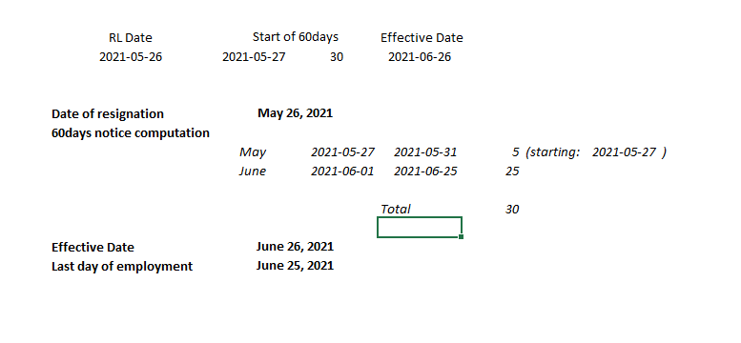

Sincerely,

[Your Name]

[Role]

**Received by:**

_______________________

<PM>/ Date

**Acknowledged by:**

LM name

Local Manager Division <n>

Akira Shimogami

Location Head, JDU (SS)

Gem Orevillo

Deputy Head/ Location Head, JDU (SS)

Hiroshi Tahata

Head of JDU

Received by:

_______________________

<PM Name / Date>

Acknowledged by:

_______________________

<Local Manager>

<Division #>

_______________________

Akira Shimogami

Location Head, JDU (SS)

_______________________

Gem Orevillo

Deputy Head/ Location Head, JDU (SS)

_______________________

Hiroshi Tahata

Head of JDU